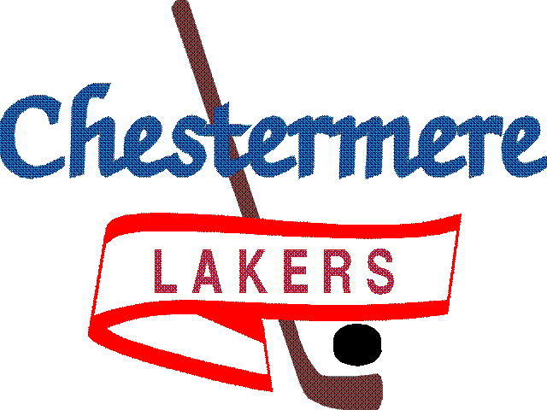

201 West Chestermere Drive Chestermere, Alberta T1X 1B2
www.chestermereminorhockey.com

CMHA PARENT / GUARDIAN PLEDGE

It is the intention of this pledge to promote proper behavior and respect for all participants within the Association. All parents are asked to sign this pledge to show their support for the principles of Fair Play.

CODE OF CONDUCT FOR PARENTS

- I will not force my child to participate in hockey.
- I will teach my child that competing and doing your best, having fun, making friends and improving skills is as important as winning. I will offer praise for competing fairly and trying his/her hardest. By doing so, my child will be a winner and not feel defeated by the outcome of the game.
- I will encourage my child to play by the rules and to resolve conflicts without resorting to hostility, or violence
- I will never ridicule or yell at any player for making a mistake or losing a game.
- I will remember that children learn by example. I will applaud good plays and performances by my child, teammates and opponents.
- I recognize officials are being developed in the same manner as players, and will not criticize their decisions during games.
- I will support all efforts to remove verbal and physical abuse from the hockey environment. I will not criticize, swear, threaten, or yell at officials, coaches, and other spectators.
- I will accept coaches’ on-ice decisions and appreciate the time that volunteer coaches give to teach my child to play hockey.
- I will respect and show appreciation for the volunteers who give their time to hockey for my child
- I understand that the use of ALCOHOL and substance abuse are not tolerated by CMHA and Hockey Alberta.

I agree to follow the CMHA Player’s Code of Conduct throughout the 2019-2020 hockey season.
I understand failure to do so will result in disciplinary action from the Coach or the CMHA.
I also agree to abide by the rules, policies and decisions as set for this Association

PRINT NAMES________________________________________________________________
DATE________________________

______________________________ ______________________________
Parent/Guardian Signature Parent/Guardian Signature

