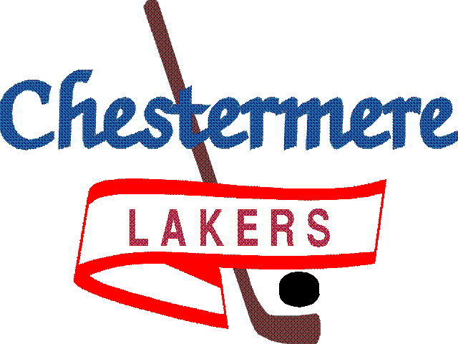

201 West Chestermere Drive Chestermere, Alberta T1X 1B2
www.chestermereminorhockey.com

CMHA PLAYER’S PLEDGE

It is the intention of this pledge to promote proper behavior and respect for all participants within the Association. All players are asked to sign this pledge to show their support for the principles of Fair Play.

CODE OF CONDUCT FOR PLAYERS

- I will play hockey because I want to, not just because my parents or others want me to.
- I will play by the rules of hockey, and in the spirit of the game.
- I will control my temper so I do not spoil the activity for everyone.
- I will respect my opponents.
- I will do my best to become a true team player.
- I will remember that winning isn’t ‘everything’. It is also important to compete, have fun, improve my skills, make friends and try to do my best.
- I will acknowledge all good plays and performances of my teammates and my opponents.
- I will remember that coaches and officials are there to help me. I will accept their decisions and show them respect.
- I understand that the use of ALCOHOL and substance abuse are not tolerated by CMHA and Hockey Alberta.

I agree to follow the CMHA Player’s Code of Conduct throughout the 2019-2020 hockey season.
I understand failure to do so will result in disciplinary action from my Coach or the CMHA.
I also agree to abide by the rules, policies and decisions as set for this Association.

PRINT NAME____________________________________________________DATE__________________
PLAYER SIGNATURE____________________________________________
TEAM NAME___________________________________________________

